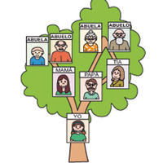
Family Tree Poster
(due Thursday 3/19. 30 pts)
Requirements:
- Letter size poster
- Must have at least 10 family members ………...5 pts
(with real or fake pictures. You choose who you include in your tree)
- Include their name and age in Spanish ……….10 pts.
(Se llama ____ , Tiene __ años)
- Include their relationship to you………………….10 pts.
(El/Ella es mi primo, etc.)
- Circle your-self on the tree
Make it presentable and be creative!............................................. 5 pts.

